Aluminum Oxide Microchannel Plates

K.Delendik, I.Emeliantchik*, A.Litomin, V.Rumyantsev, O.Voitik

Introduction

At present microchannel electron multipliers (or microchannel plates - MCP) are widely used in different fields of science and technology. MCP have good operational parameters: gain up to 10⁶, response time 1 ns and less, spatial resolution of the order of channel diameter, sensitivity up to single electron mode, high radiation hardness, ability to work in strong magnetic fields.. MCP are used in brightness amplifiers, navigation equipment, electron-optic converters, scientific measuring devices, medical diagnostic equipment, night vision devices, detectors of charged particles and gamma-quanta etc.

Existing MCP and technology of their production

MCP is a matrix of parallel microchannels. Each microchannel can be considered as a continuous dynode structure having necessary resistive and secondary-emissive properties.
Concept of continuous dynode of channel type was formulated by Farnswort (1930) [1], the first operating prototype of MCP was created by I.Pesyatsky (1943) [2].. In 1960s technology of MCP was actively developed [3-6]. The basic elements of modern MCP technology were created at that time.
Modern MCPs are plates with thichness of 0.4 - 4 mm, having channels with diameters of 10 - 100 mcm with package density up to 10⁶ см⁻². Due to small dimensions of channels MCP has good time resolution (hundreds of picoseconds) and spatial resolution (comparable with channel diameter), the gain is up to 10⁵. MCP channels are usually slightly tilted (5°-15°) in relation to the perpendicular to the plate surface, which is diminishing parasitic ion feedback.
Currently the main material for MCP production is lead-silicate glass. Modern technology of lead glass MCP production is based on methods of optic fibers production and consists of multiple processes of dragging and agglomeration of fibers having soluble metal or glass core resulting in production of primary multivein fibers. Then the block is cut under certain angle into separate plates, their surfaces are being polished. Thermohydrogen reduction provides necessary electrophysical parameters of MCP and consists of reduction of lead oxide in the surface area of channels by heating of MCP in the hydrogen flow. It's necessary to maintain precise time-temperature profile of hydrogen reduction, which complecates lead glass MCP technology.

Shortcomings of existing MCP technology

Lead glass MCP have good parameters, but there are also serious disadvantages:
- very complex, labour consuming and expensive technology;
- large parameter deviation and low repeatability of MCP due to possible glass irregularities;
- large deviation of channel diameters within MCP;
- spottiness of the image due to difference of thermal histories of elements of MCP block;
- during MCP production the glass undergoes different influences: thermochemical, mechanical, chemical, which causes defects due to plate deformations caused by changes of glass composition and its temperature expansion coefficient;
- limit of spatial resolution is already reached - channels with diameters less than 10 mcm are impossible to produce with conventional methods;
- it's difficult to produce llarge area MCP.

Attempts to create alternative technology

So, development of the alternative MCP technology, less expensive and able to produce MCP with larger area and smaller channel diameters, is quite urgent.
There were many attempts to create new MCP technology during the last 20 years. In [7] multilayer structure made of etched glass plates is proposed. In [8] and [9] microshere plates made of agglomerated glass balls are described. In patents [10 - 18] different versions of microchannel structures made of glass, ceramics and other materials, and methods of creation of conductive and secondary emissive layers, are proposed. But despite abundance of publications, new MCP technology, able to replace the conventional one, is still not created.

Anodic aluminum oxide
2μm
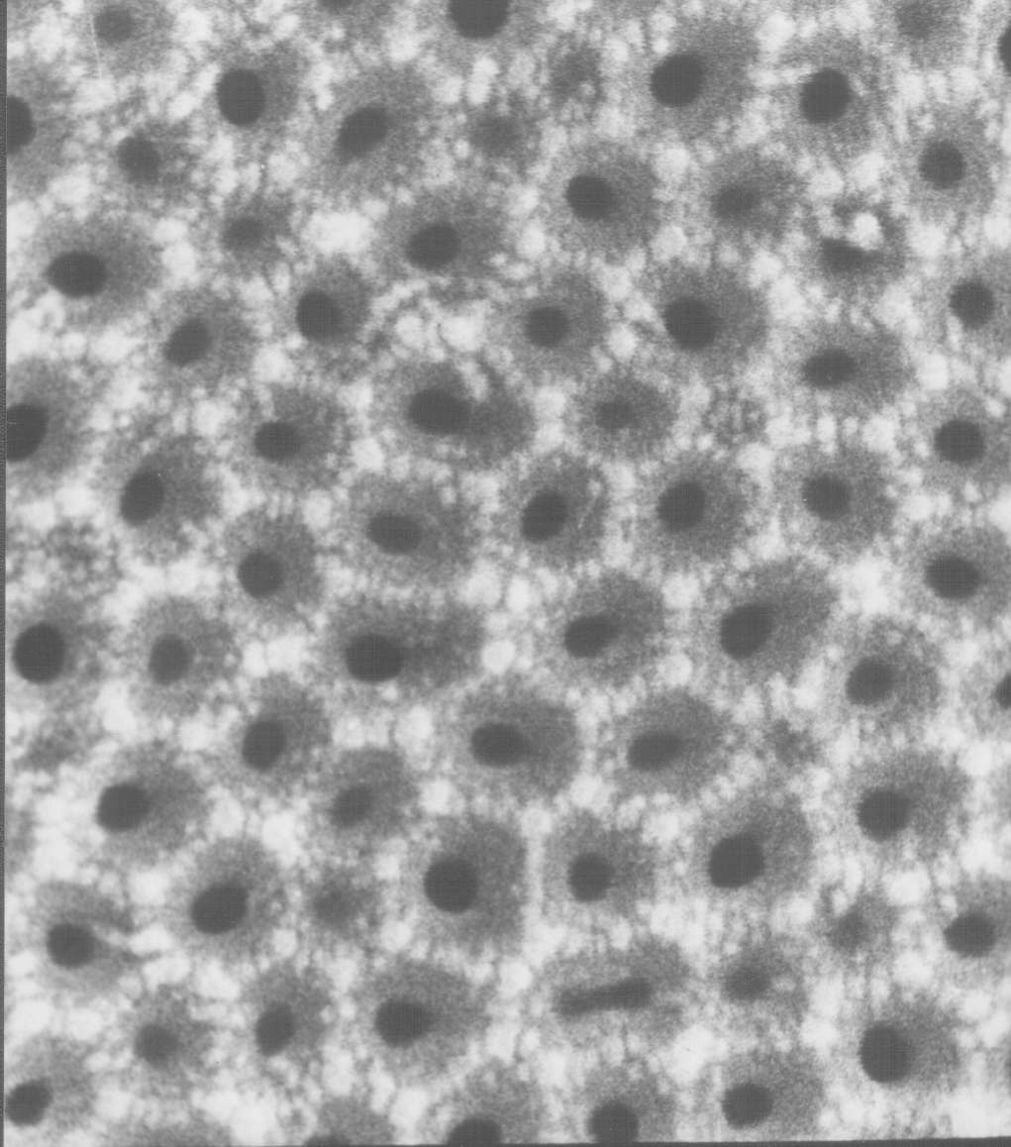
Fig. 1. Natural pores of anodic aluminum oxide. View from above.

We propose new material for MCP production: anodic aluminum oxide. It is being formed by electrochemical oxidation of aluminum in electrolytes, weakly dissolving alumina and consists of regular hexagonally packed cells, which are parallel to each other and perpendicular to the surface of aluminum substrate (fig. 1 and 2).
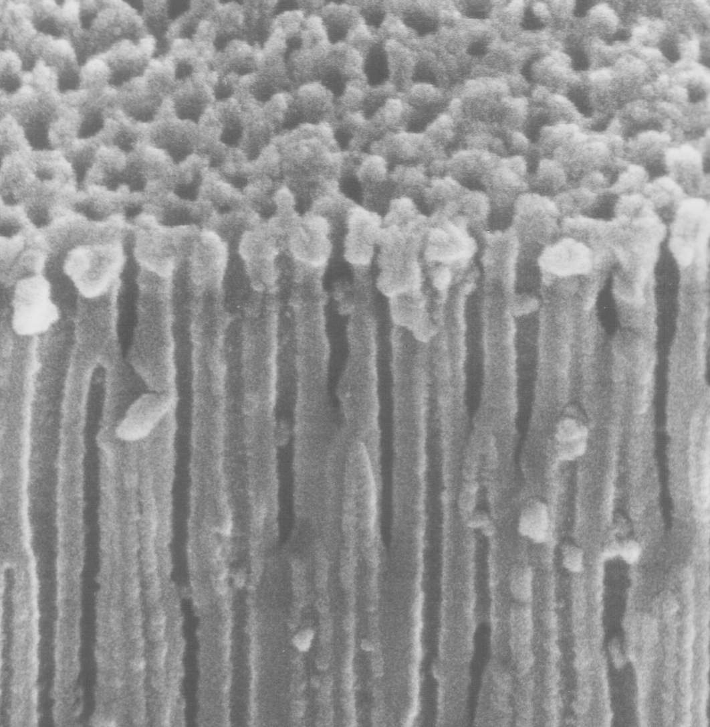
3μm

Fig. 2. Anodic aluminum oxide. Side view.

Each cell has axial pore, closed by the barrier oxide layer on the side of aluminum anode (fig. 3). The cell diameter is mainly defined by the anodization voltage. Cell diameter rating is about 2.5 - 3.0 nm per volt of anodizing voltage.
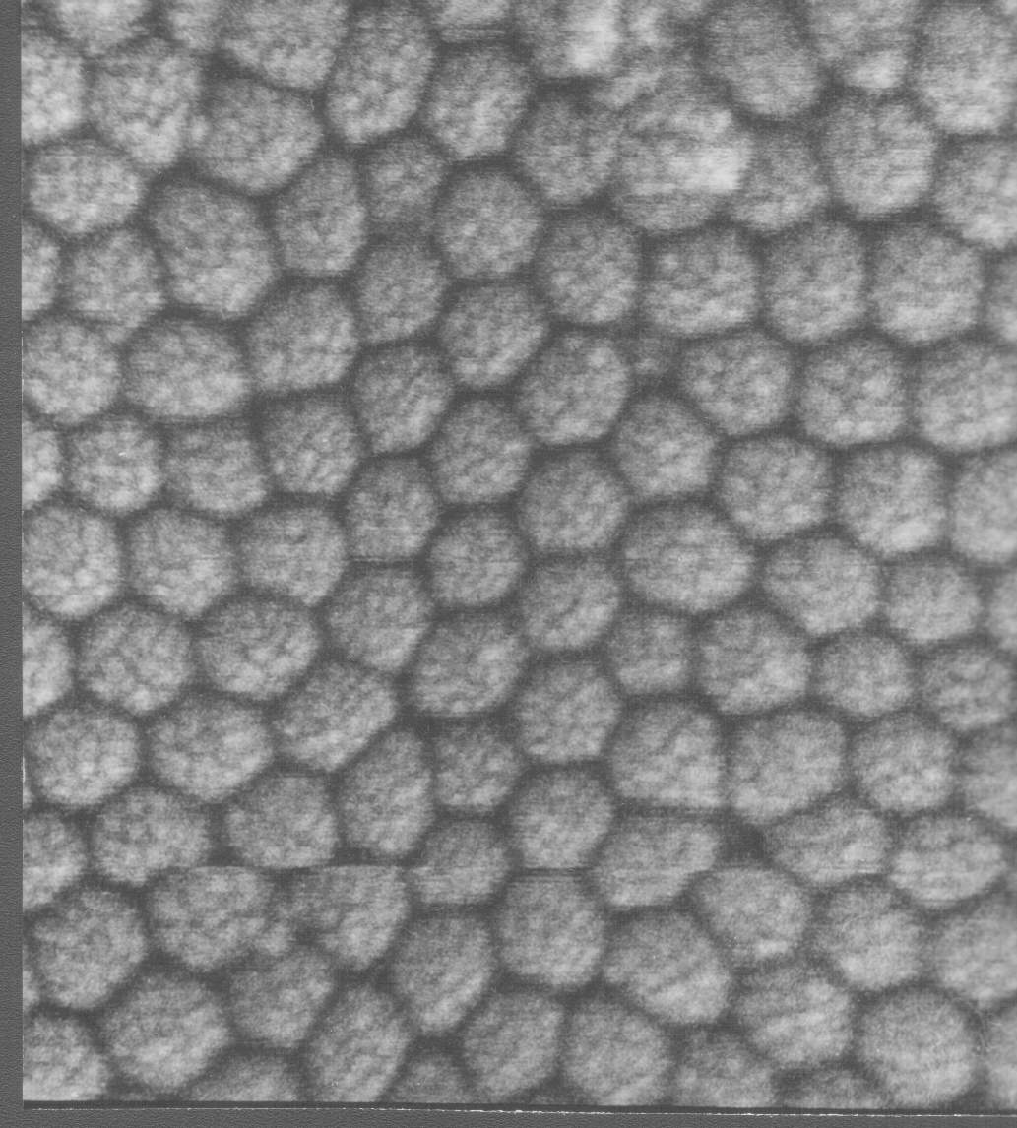
3μm

Fig.3. Barrier layer of anodic aluminum oxide

Diameter of the pore depends on the electrolyte nature, its temperature and concentration, the current density and other parameters of anodization process. It is possible to vary the diameters of the cell and the pore by variation of the electrolyte composition and anodization conditions. The pore diameter can also be enlarged by selective etching of cell walls. Anodic alumina is a very suitable material for microchannel plates due to presense of natural microchannels [19]. Diameters of these channels lie in the range of 0.02 - 0.5 μm, channels of greater diameter can be easily produced by means of additional processing based on the presence of intrinsic microchannel structure. It is possible to produce MCPs with channel diameters 0.2 - 8 μm and thickness 40 - 150 μm.

Potential advantages of aluminum oxide technology

The main advantage of aluminum oxide MCP technology is formation of microchannel structure by means of group methods (instead of individual dragging of fibers with consequent agglomeration). It provides considerable reduction of prices of MCP production. Possibility to use standard microelectronics technological processes on all stages of MCP production also helps to further reduce prices. Group methods of microchannel structure formation allows also to produce MCP of significantly larger area than it's possible with conventional technology. Channel diameters cam be made considerably smaller (down to submicron region), which increases resolution and ability to work in strong magnetic fields.

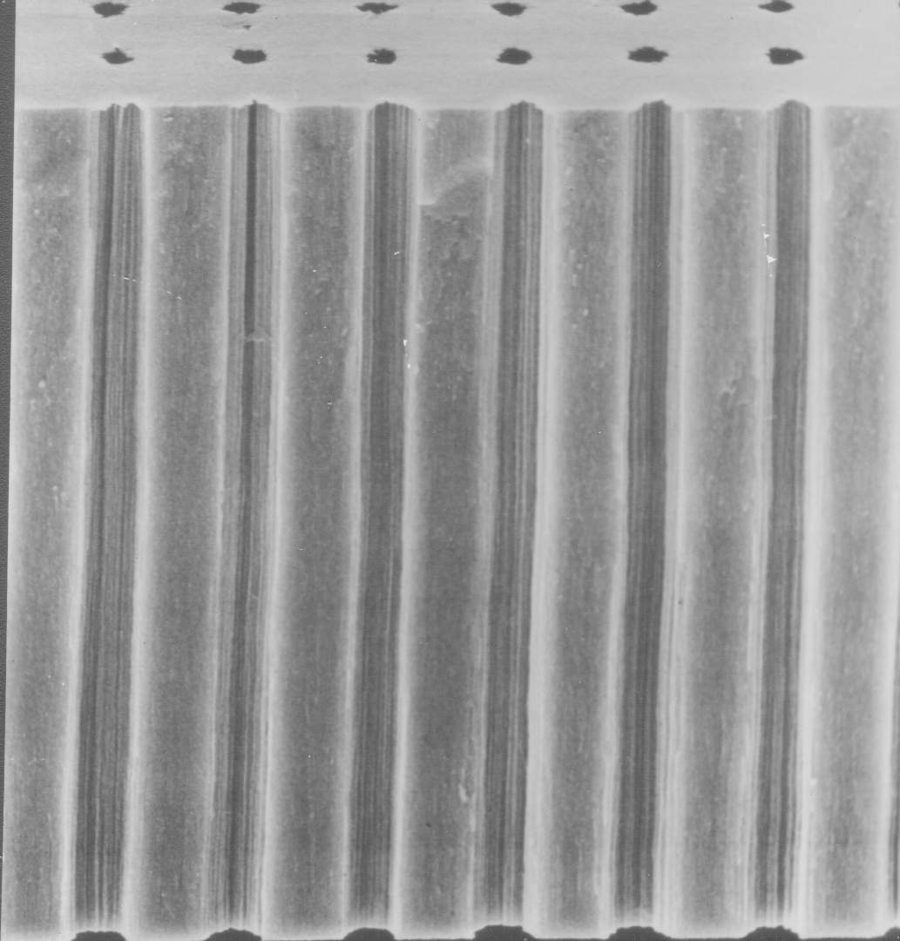
Brief description of the method of alumina MCP production
100 μm

Fig. 4. MCP with etched channels

We have developed a procedure of anodic alumina MCP production [20 - 22] which consists of next stages:
- growing of anodic alumina of necessary thickness;
- separation of alumina plate from aluminum substrate;
- deposition of photolithographic mask;
- protection of nonoperational surface;
- etching of alumina through protective mask in multicomponent acidic and alkaline etchants;
- liberation of MCP matrix;
- annealing of MCP matrix.

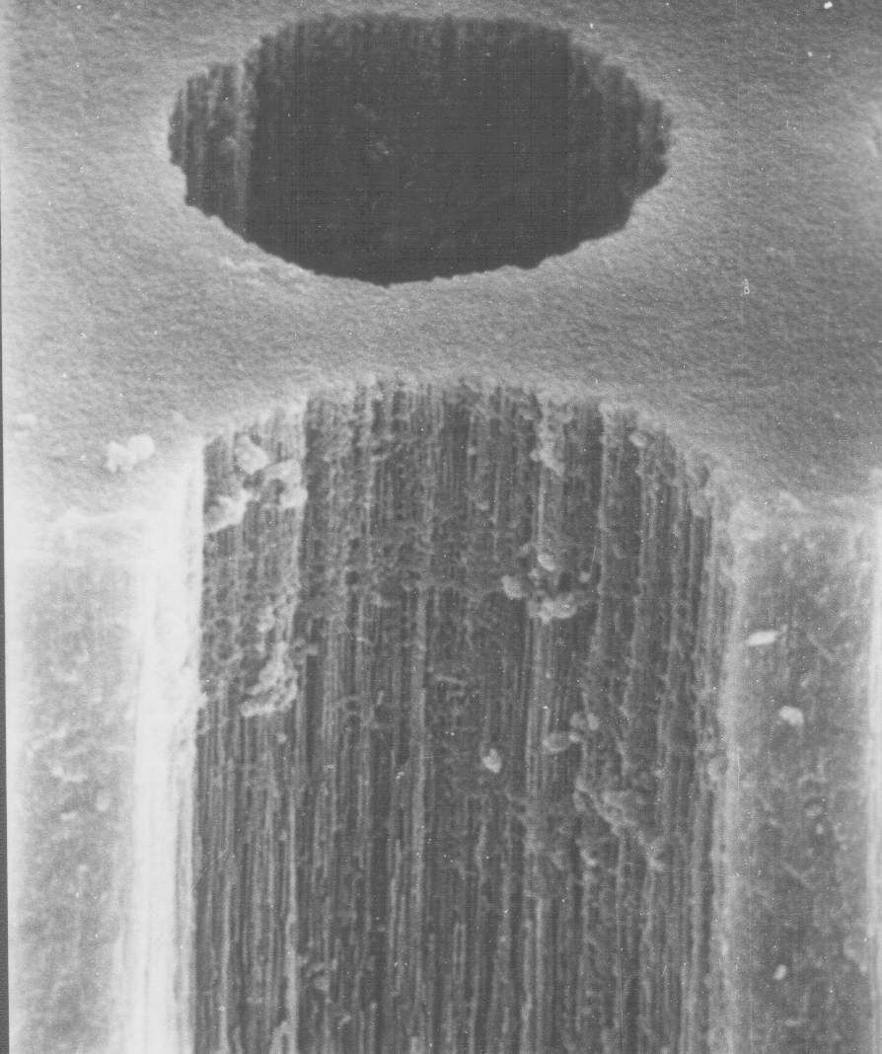
MCP produced with that procedure is shown on the fig. 4. Fig. 5 presents magnified picture of one of the channels of that MCP.
15 μm

Fig. 4. Magnified view of the etched channel of anodic alumina MCP

Coating problem

Anodic aluminum oxide is typical dielectric, so it's necessary to create conductive and emissive coating on the walls of MCP channels to use it as electron multiplier. It can be done by deposition of oxide films with suitable properties on the walls of MCP channels.
Deposition of regular homogenious coatings with controllable electrophysical properties and good adhesion to the walls of deep narrow channels is a difficult problem. We have tested a large variety of methods of deposition of such coatings, including
- MCP impregnation in acetate, nitrate and oxalate salt solutions with consequent drying and thermic decomposition resulting in creation of oxide films on channel walls;
- deposition of oxide films on channel walls by means of decomposition of hydrooxipolimers of metals produced by sol-gel method;
- deposition of glass-enamel coatings by means of co-precipitation of components from solutions on the base of tetraetoxisilane (creation of coatings having composition close to that of standard lead-glass MCP)
- deposition of oxide coatings by MCP impregnation in alcohol solutions of oxides of acid-forming metals;
- deposition of metals on the channel walls by means of thermic "explosion" sputtering with consequent oxidation.
Unfortunately, thus made oxide coatings had nonstable electrochemical parameters due to nonhomogenious structure and bad adhesion to alumina. So we've developed new methods of oxide film deposition directed specifically to deposition of thin homogenious coatings on the walls of deep narrow channels
Deposition of thin oxide films from liquid phase and by means of plasma sputtering, and description of MCPs made by these methods

We've developed two methods of coating formation: deposition from liquid metallo-organic precursors with consequent annealing and deposition of discontinuous metal film by plasma sputtering with consequent partual oxidation. We also tested hybrid coating deposition procedure consisting of formation of partually oxidized metal film by means of plasma sputtering with consequent deposition of oxide of different metal from liquid phase.
For liquid phase deposition we used solutions of metal acetylacetonates. During annealing of acetylacetonate films the organic ligands are evaporating leaving dense homogenious oxide films with good adhesion to the surface. The best results were achieved with complex nickel-magnesium coating. Nickel oxide film was deposited first, and served to provide conductivity. Then on the top of it the magnesium oxide film was deposited, which served to provide secondary electron emission.
Method of plasma sputtering was used to deposit discontinuous film of berillium bronze which was then partually oxidized by means of heating in air atmosphere. Conductivity of such a film was more stable than that of nickel oxide film deposited from liquid phase, but its secondary emissive properties were worse than that of of the nickel-magnesium coating.
So the hybrid procedure was used where the magnesium oxide film was deposited from liquid phase on the top of berillium bronze oxide film deposited by plasma sputtering. Such a coating was combaining stable conductivity with high secondary emission coefficient.
MCP modified with all these three methods had resistivity about 1 GOhm (MCP area was 1 cm² and thickness 100 μm). Conventional lead glass MCP have similar resistivity.
Coefficient of secondary electron emission of coatings containing magnesium oxide was rather high, probably higher than that of conventional lead glass MCP.
We've put MCPs of all three described above types in vacuum and applied input electron beam. In all three cases there was prevalence of output current over input current, which proves electron multiplication. The gain calculated as ratio of output to input currents, happen to be more than 1000 for plates modified with nickel-magnesium coating deposited from liquid phase, about 20 for plates with hybrid berillium-bronze-magnesium coating, and about 1.5 for plates with berillium-bronze coating.
During investigation of electron multiplication in the produced microchannel structures we discovered effect of parasitic spontaneous electron emission. Some output current, which is not a conductivity current, exists even in the absence of exiting input electron beam. That is, the plate is multiplying its own electrons spontaneously emitted from channel walls. This effect exists in all three types of MCP coatings, and is most intensive in case of NiO-MgO coating, probably due to the biggest coefficient of secondary electron emission of that coating.
The effect of spontaneous electron emission is probably caused by nonflat surface of channel walls leading to significant fluctuations of electric field. The mechanism of spontaneous electron emission is probably similar to Malter effect, which was studied in details exactly for anadic aluminum oxide, of which our MCP are made.
Nonflatness of the surface of channel walls is due to currently used procedure of microchannel structure formation - directional etching of anodic alumina already having natural pores. Such a procedure allows to form microchannel structures with optimal for research purposes ratio of channel length to its width - from 10 to 20. Howerver the channel walls produced by this procedure have very complex relief created by sharp partually etched remnants of pores. Currently we are looking for solution of this problem.

Conclusion

Our research proves that anodic aluminum oxide technology is a promising alternative to convinient lead glass MCP. It has potential to make MCP much cheaper, easier to produce, to increase spatial resolution of detectors on the base of MCP, to improve their ability to work in strong magnetic fields.

References

- Farnsworth ,Electron Multiplier, U.S. Patent N. 969,399 (1930).
- Author Certificate No 62669 // Bulleten of Inventions - 1943 - No 4 - 5, p. 63-71.
- P.K. Oschepkov, B.N. Skvortsov, B.A. Osanov and I. Siprikov, Pribory. Tekh. Eksper. 4 (1960) 89.
- G.W. Goodrich and W.C. Willey, Rev. Sci. Instr. 33 (1960) 761.
- J. Adams and B.W. Manley, Electron Eng. 37 (1985) 180.
- J. Adams and B.W. Manley, IEEE Trans. Nucl. Sci. (1966) 88.
- W.Baumgartner, U.Zimmermann. A High-gain Channel Electron Multiplier (CEM) Array and Some of Its Operational Characteristics. Advances in Electronics and Electron Physics, 18, 1971, p.125
- R.Naaman, Z.Vager. An electron multiplier capable of working at low vacuum: The microsphere plate. Rev. Sci. Instrum. 67 (9), September 1996, p.3332
- A.Tremsin, J.Pearson, J.Lees, G.Fraser. The Microsphere Plate: a new type of electron multiplier. NIM A, 368 (1996) p.719

US patent 3,967,001. Process of preparing a secondary electron emissive coating on the interior walls of a microchannel plate
- US patent 4,073,989. Continuous channel electron beam multiplier.
- US patent 4,825,118. Electron multiplier device.
- US patent 4,950,939. Channel electron multipliers.
- US patent 5,172,069. Secondary electron multiplying apparatus.
- US patent 5,378,960. Thin film continuous dynodes for electron multiplication.
- US patent 5,439,753. Electron emissive film.
- US patent 5,624,706. Method for fabricating electron multipliers.
- US patent 5,726,076. Method of making thin film continuous dynodes for electron multiplication.
- Delendik K. I., Voitik O. L. Anodic alumina as material for high-aspect ratio microstructures // Proceeding of Fourth International Workshop on High-Aspect-Ratio Micro-Structure Technology. June 2001. Baden-Baden, Germany. 2pp.)
- F. Emel'yanchik , A.S. Kurilin, V. N. Kukhnovetc et al. Submicrochannel plate multipliers, Applied Surface Science, 111 (1997) Р.295-301;
- Govyadinov, I. F. Emel'yanchik, A.S. Kurilin. Anodic aluminum oxide microchannel plates, Nuclear Instruments and Methods in Physics Research, A 419 (1998) 667-675).:
- . Emeliantchik I.F., Rumyantsev V.S. et.al. Development and creation of new types of detectors and readout electronics for modern and future experiments in particle and high energy physics. Selected scientific papers of BSU, Minsk-2001, p.303-322.

